Forces holding polypeptide together
Van der Waals interactions
The basis of a van der Waals interaction is that the distribution of electronic charge around an atom changes with time. At any instant, the charge distribution is not perfectly symmetric. This transient asymmetry in the electronic charge around an atom acts through electrostatic interactions to induce a complementary asymmetry in the electron distribution around its neighbouring atoms.
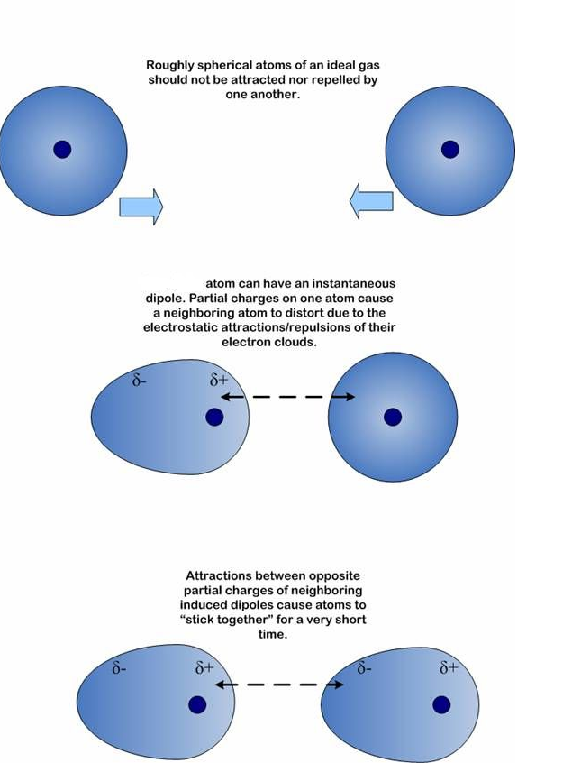
The resulting attraction between two atoms increases as they come closer to each other, until they are separated by the van der Waals contact distance. At a shorter distance, very strong repulsive forces become dominant because the outer electron clouds overlap.
Electrostatic forces
Electrostatic interactions are between and among cations and anions, species with formal charge of ...-2,-1,+1,+2... Electrostatic interactions can be either attractive or repulsive, depending on the signs of the charges. Like charges repel. Unlike charges attract.
Favourable electrostatic interactions between paired anionic and cationic amino acid sidechains are reasonably frequent in proteins. Ion Pairs, sometimes called Salt Bridges, are formed when the charged group of a cationic amino acid (like lysine or arginine) is around 3.0 to 5.0 Å from the charged group of an anionic amino acid (like aspartate or glutamate). The charged groups in an ion pair are generally linked by hydrogen bonds, in addition to electrostatic interactions.
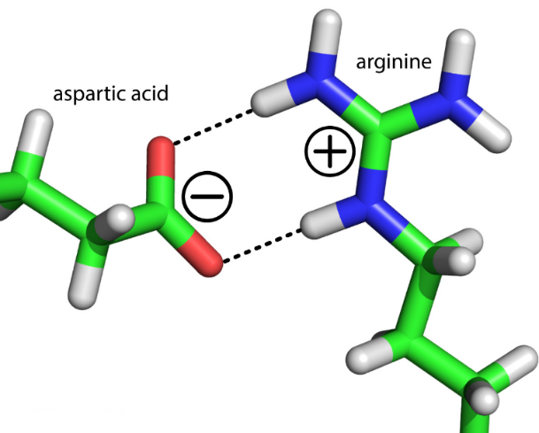

Hydrogen bonds
Hydrogen bonds are relatively weak interactions, which nonetheless are crucial for biological macromolecules such as DNA and proteins. These interactions are also responsible for many of the properties of water that make it such a special solvent. The hydrogen atom in a hydrogen bond is partly shared between two relatively electronegative atoms such as nitrogen or oxygen. The hydrogen-bond donor is the group that includes both the atom to which the hydrogen is more tightly linked and the hydrogen atom itself, whereas the hydrogen-bond acceptor is the atom less tightly linked to the hydrogen atom. Hydrogen bonds are fundamentally electrostatic interactions. The relatively electronegative atom to which the hydrogen atom is covalently bonded pulls electron density away from the hydrogen atom so that it develops a partial positive charge (δ⁺). Thus, it can interact with an atom having a partial negative charge (δ⁻) through an electrostatic interaction.
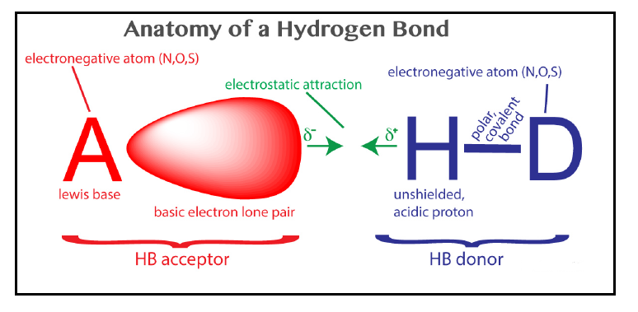
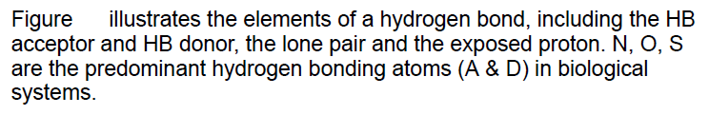
A hydrogen bond is a favorable interaction between an atom with a basic lone pair of electrons (a Lewis Base) and a hydrogen atom that has been partially stripped of its electrons because it is covalently bound to an electronegative atom (N, O, or S). In a hydrogen bond,
the Lewis Base is the hydrogen bond acceptor (A) and the partially exposed proton is bound to the hydrogen bond donor (H-D).
Hydrogen is special because it is the only atom that:
- forms covalent sigma bonds with electronegative atoms like N, O and S.
- uses the inner shell (1S) electron(s) in that covalent bond.
When its electronegative bonding partner pulls the bonding electrons away from hydrogen, the hydrogen nucleus (a proton) is exposed on the back side (distal from the bonding partner). The unshielded face of the proton is exposed, attracting the partial negative charge of an electron lone pair. Hydrogen is the only atom that exposes its nucleus this way. Other atoms have inner shell nonbonding electrons that shield the nucleus.
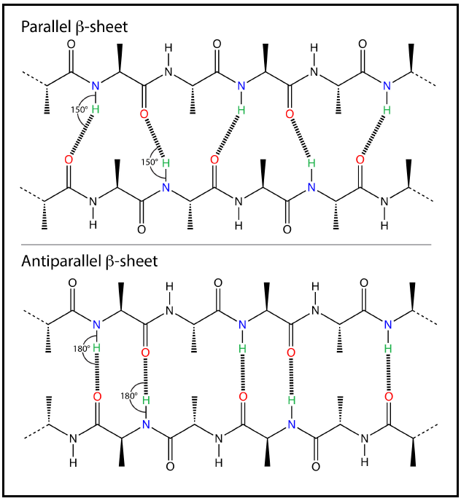
Figure: hydrogen bonds in proteins.
Hydrophobic interactions
Amphipathic compounds contain regions that are polar (or charged) and regions that are nonpolar. When an amphipathic compound is mixed with water, the polar, hydrophilic region interacts favourably with the solvent and tends to dissolve, but the nonpolar, hydrophobic region tends to avoid contact with the water. The nonpolar regions of the molecules cluster together to present the smallest hydrophobic area to the aqueous solvent, and the polar regions are arranged to maximize their interaction with the solvent. When water surrounds
a hydrophobic molecule, the optimal arrangement of hydrogen bonds results in a highly structured shell, or solvation layer, of water in the immediate vicinity. The tendency of nonpolar molecules in a polar solvent (usually water) to interact with one another is called the hydrophobic effect. The forces that hold the nonpolar regions of the molecules together are called hydrophobic interactions.

The strength of hydrophobic interactions is not due to any intrinsic attraction between nonpolar moieties. Rather, it results from the system’s achieving greatest thermodynamic stability by minimizing the number of ordered water molecules required to surround hydrophobic portions of the solute molecules. Hydrophobic interactions between nonpolar amino acids also stabilize the three-dimensional structures of proteins.

